Long term plan
Half Term | Autumn 1 | Autumn 2 | Spring 1 | Spring 2 | Summer 1 | Summer 2
Topic | All about me | Celebrations | Dinosaurs | People who help us | Into the Garden | The World around me
RE- Lighting the path scheme | Creation and Covenant  Nursery: Exploring the wonder of the world around us, developing curiosity about people, animals and nature and beginning to understand that stories can teach us important messages. Reception: Exploring stories about Creation and developing an understanding of God as creator, recognising that Christians believe the world is special and should be cared for. | Prophecy and Promise  Nursery: Listening to and joining in with special stories, celebrations and traditions, beginning to recognise that people have different beliefs and ways of showing they care. Reception: Exploring stories of promise and hope, recognising that Christians believe God’s promises are important and linking these to celebrations and traditions. | Galilee to Jerusalem  Nursery: Exploring stories about Jesus, developing understanding that stories can teach us how to be kind, caring and helpful towards others. Reception: Learning about Jesus’ life, exploring stories from Galilee to Jerusalem and understanding how Jesus showed love, kindness and care for others. | Desert to Garden  Nursery: Exploring ideas of change, new life and special events through stories, nature and celebrations. Reception: Exploring stories of Easter and the journey from the desert to the garden, beginning to understand themes of change, hope and new life. | To the Ends of the Earth  Nursery: Beginning to understand that stories, people and communities can share messages and experiences with others. Reception: Exploring how Christian messages spread, learning about the disciples and how people share beliefs and stories with others around the world. | Dialogue and Encounter  Nursery: Developing respect and curiosity about others, recognising that people may have different celebrations, beliefs and experiences. Reception: Exploring different beliefs and traditions, developing respect for others and understanding the importance of listening, talking and learning from each other.
Literacy- Talk through stories scheme | Owl Babies – Martin Waddell – Families, separation, reassurance and feelings. Ruby’s Worry – Tom Percival – Recognising worries, emotions and talking about our feelings. Hugless Douglas – David Melling – Friendship, affection and relationships. | Winnie the Witch – Valerie Thomas – A fun, magical story that works well alongside Halloween and seasonal celebrations. Room on the Broom – Julia Donaldson – Friendship, teamwork and seasonal storytelling. Handa’s Hen – Eileen Browne – Exploring another culture, community and experiences beyond our own. | How to Be a Viking – Cressida Cowell – Exploring the past, historical ideas and imaginative storytelling. The Slightly Annoying Elephant – David Walliams – A strong imaginative text for developing storytelling, character and descriptive vocabulary. | Burglar Bill – Janet & Allan Ahlberg – Exploring right and wrong, choices and links to police/community roles. I’m in Charge – Jeanne Willis – Responsibility, rules, leadership and making choices. On the Way Home – Jill Murphy – Community, journeys, people and imaginative explanations. | Cottonwool Colin – Jeanne Willis – Animals, independence and exploring the wider world. One Snowy Night – Nick Butterworth – Woodland animals, habitats, weather and caring for others. | Lost and Found – Oliver Jeffers – Journeys, different environments, friendship and the wider world. The Rainbow Fish – Marcus Pfister – Sea life, friendship and sharing. Can’t You Sleep, Little Bear? – Martin Waddell – Light, dark, night-time and the natural world.
Nursery Rhymes | Head, Shoulders, Knees and Toes • If You’re Happy and You Know It • One Finger, One Thumb, Keep Moving • Tommy Thumb  Chosen to support children in learning about themselves, naming parts of their body, recognising feelings and developing body awareness. The action rhymes also encourage listening, coordination and physical development. | Happy Birthday • Oranges and Lemons • Ring-a-Ring o’ Roses • Here We Go Round the Mulberry Bush  Chosen to encourage children to sing and participate together. These rhymes provide opportunities to talk about birthdays, celebrations, traditions and special times shared with families and communities. | The Grand Old Duke of York • Five Little Monkeys • One, Two, Three, Four, Five • Ten in the Bed  Chosen for their strong links to movement, counting, size and positional language. Children can adapt the actions to stomp, march and move like dinosaurs while developing their understanding of number. | The Wheels on the Bus • Miss Polly Had a Dolly • London’s Burning • Pat-a-Cake  Chosen to introduce different people, occupations and services within the community. The rhymes provide opportunities to talk about drivers, doctors, firefighters and people who make or provide things for us. | Mary, Mary, Quite Contrary • Incy Wincy Spider • Five Little Speckled Frogs • Two Little Dickie Birds  Chosen to develop children's knowledge of gardens and the natural world. They introduce plants, weather, minibeasts, birds and other creatures children may discover when exploring outdoors. | Old MacDonald Had a Farm • Five Little Ducks • Row, Row, Row Your Boat • Twinkle, Twinkle, Little Star  Chosen to broaden children's understanding of the world beyond their immediate environment. The rhymes explore animals, water, journeys and the night sky while encouraging curiosity about the wider world.
Communication and Language | Nursery – Listen Developing attention and listening skills through songs, rhymes, stories and everyday interactions, learning to listen, respond and follow simple instructions with support. Reception – Listen Learning to use active good listening skills, understanding why listening is important and developing the ability to listen and respond to stories, songs and conversations. | Nursery – Connect Building confidence in communication by using words and phrases to talk with adults and peers, beginning to take turns and respond during simple conversations. Reception – Connect Developing conversations with adults and peers, using social phrases, simple back-and-forth exchanges and responding appropriately in different situations. | Nursery – Respond Listening to familiar stories, songs and rhymes, joining in with repeated words and phrases and beginning to answer simple questions using familiar vocabulary. Reception – Respond Using recently introduced vocabulary to respond to questions, talk about stories and demonstrate understanding through conversations and discussion. | Nursery – Express Using simple sentences to share experiences, thoughts and feelings, developing confidence to communicate ideas through play and conversations. Reception – Express Sharing experiences, thoughts and ideas using full sentences, recently introduced vocabulary and developing confidence in spoken language. | Nursery – Discuss Developing conversations with others by listening, responding and beginning to share ideas, describe experiences and talk about familiar stories. Reception – Discuss Developing sustained conversations, retelling familiar stories and sharing ideas, opinions and feelings with others. | Nursery – Explain Beginning to explain choices, ideas and thinking using developing vocabulary and longer sentences, answering simple questions about experiences and the world around them. Reception – Explain Explaining ideas, solving problems and organising thinking using recently introduced vocabulary, full sentences, conjunctions and reasoning language.
Physical Development | play/move/explore Nursery: Exploring different ways of moving through play, developing confidence, body awareness and awareness of the space around them. Reception: Developing a wider range of movements through play, moving with increasing control and confidence and exploring how their body can move in different ways. | move/match/magic Nursery: Exploring different movements and beginning to copy and match simple actions demonstrated by others. Reception: Developing coordination and control by copying, matching and combining movements, using imagination to explore different ways of moving. | explore/evade/escape Nursery: Exploring space and beginning to change direction and move around people and objects safely. Reception: Developing agility and spatial awareness, changing speed and direction and learning to evade and move safely away from others during games. | search/steal/share Nursery: Taking part in simple physical games, searching for and collecting objects and beginning to share space and equipment with others. Reception: Developing cooperation and decision-making through games involving searching, collecting and sharing, while beginning to use simple tactics and follow rules. | crawl/climb/collect Nursery: Exploring crawling, climbing and travelling in different ways, developing confidence when using equipment and collecting objects. Reception: Developing strength, balance and coordination through crawling, climbing and travelling, using equipment with increasing control and confidence. | hands/feet/equipment Nursery: Exploring how hands, feet and different equipment can be used to move, control and interact with objects. Reception: Developing increasing control and coordination when using hands, feet and equipment, applying physical skills with greater accuracy and confidence.
My happy mind scheme | Meet your Brain | Celebrate | Appreciate | Relate | Engage | Consolidate
Personal, Social and Emotional Development | Self-regulation  Nursery: Beginning to understand the language of feelings, recognise emotions and communicate how they feel with support. Learning to wait for short periods, manage small frustrations and follow simple routines and expectations. Reception: Developing an understanding of their own feelings and those of others, beginning to regulate emotions, manage impulses, persevere with challenges and work towards achievable goals. |  | Managing self  Nursery: Developing confidence and independence by trying new activities with support, following simple rules and routines and managing basic personal needs and hygiene with increasing independence. Reception: Developing independence, confidence and resilience when trying new activities, understanding why routines and rules are important and making healthy choices to support wellbeing. |  | Building Relationships  Nursery: Building positive relationships with adults and peers, learning to play alongside others, share, take turns and begin to understand how others may feel. Reception: Developing respectful relationships, cooperating and resolving conflicts, showing sensitivity towards others’ feelings and needs and understanding that everyone is valued and important.
Expressive Arts and Design | Self Portraits  Nursery: Exploring mark making, colour and materials to create representations of themselves, developing control when using pencils, paint and different tools. End Creation: A self-portrait using a range of materials. Reception: Developing confidence in representing themselves through drawing, painting and mixed media, making choices about materials and techniques. End Creation: A detailed self-portrait showing personal features and creative choices. | Collage  Nursery: Exploring how different materials can be combined, layered and stuck together to create simple pictures and designs. End Creation: A celebration collage using a variety of textures and materials. Reception: Selecting and combining materials to create purposeful collages, experimenting with colour, texture, shape and pattern. End Creation: A detailed collage inspired by celebrations and experiences. | Modelling  Nursery: Exploring how materials can be shaped, joined and manipulated to create simple models using imagination and play ideas. End Creation: A dinosaur model or imaginative sculpture. Reception: Developing control when using malleable materials, joining techniques and tools to design and create models. End Creation: A detailed prehistoric model or sculpture. | Painting & Printing  Nursery: Exploring colour, brush skills, printing and mark making, developing confidence to experiment with different tools and techniques. End Creation: A painting or printed artwork linked to people who help us. Reception: Exploring how artists use colour, line, shape and pattern, selecting techniques to communicate ideas and feelings. End Creation: A painting or printed artwork showing developed skills and creativity. | Natural Art  Nursery: Exploring natural objects, textures and materials to create artwork inspired by the garden and outdoor environment. End Creation: A nature-inspired creation using natural materials. Reception: Experimenting with natural materials, texture, colour and form to create artwork inspired by the natural world. End Creation: A detailed nature artwork or mixed-media creation. | Creative Expression  Nursery: Exploring music, movement, role play and materials to express ideas, stories and imagination. End Creation: A creative performance or imaginative artwork. Reception: Combining skills across art, music, movement and drama to express ideas, develop storylines and perform creatively. End Creation: A final creative performance, artwork or project celebrating skills developed across the year.
Understanding the World | All About Me  Nursery: Exploring what makes us special, talking about ourselves, our families and similarities and differences between ourselves and others. Reception: Developing an understanding of ourselves, our families and communities, recognising that people may have different cultures, beliefs and experiences. | Celebrations  Nursery: Exploring celebrations, traditions and special events, beginning to recognise that people celebrate in different ways. Reception: Exploring celebrations in different cultures and communities, recognising similarities and differences and developing respect for the beliefs and traditions of others. | Dinosaurs  Nursery: Beginning to explore the past through stories and familiar characters, noticing changes over time and developing curiosity about things that existed before now. Reception: Exploring dinosaurs and the past, comparing past and present and developing an understanding of how we know about things that happened long ago. | People Who Help Us  Nursery: Learning about people who help us at home, school and in our community, understanding the important roles they have. Reception: Developing an understanding of people who help us locally and around the world, recognising how communities work together. | Into the Garden  Nursery: Exploring the natural world, seasonal changes, plants and living things, observing and describing what we see, hear and feel outside. Reception: Exploring life cycles, seasonal changes and the natural world, making observations and understanding how living things grow and change. | The World Around Me  Nursery: Exploring the world around us, noticing similarities and differences in environments, materials and living things through investigation and play. Reception: Exploring contrasting environments, materials and forces, making observations, investigating how things work and describing changes in the world around us.
Music- Charanga Scheme | Me | My Stories | Everyone | Our World | Big Bear Funk | Reflect, Rewind and Replay

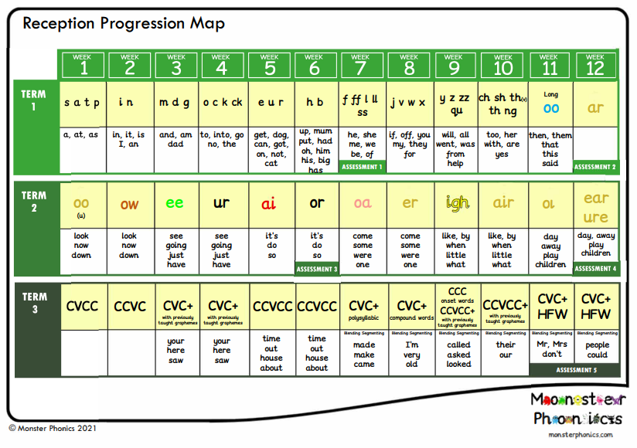
Reception Phonics

Nursery Maths
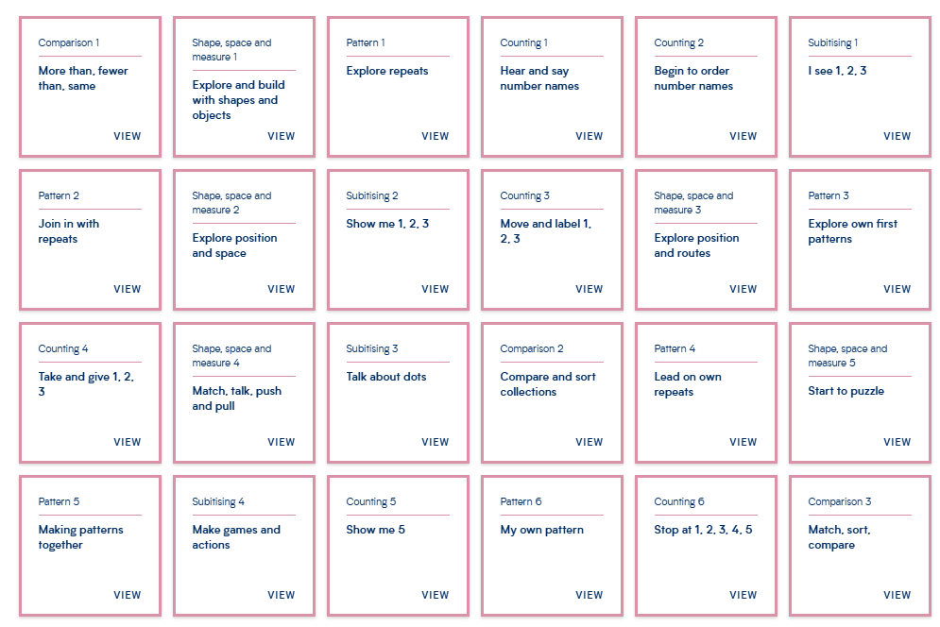
Reception Maths
